Parc-4  
  
Objective-1  
  
test cases:  
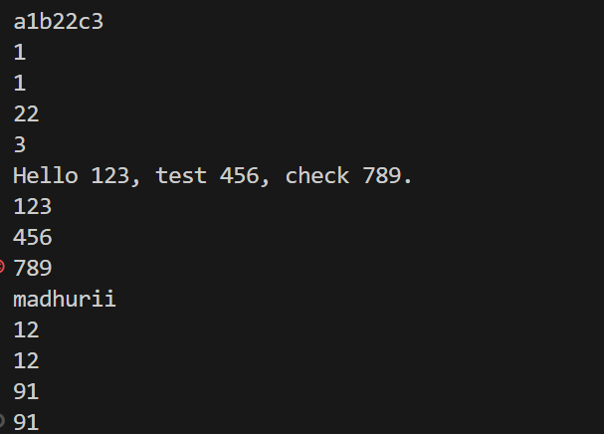

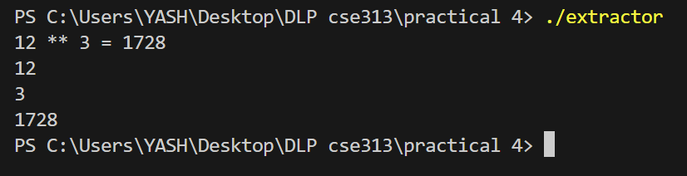

Objective-2  
  
test cases:  
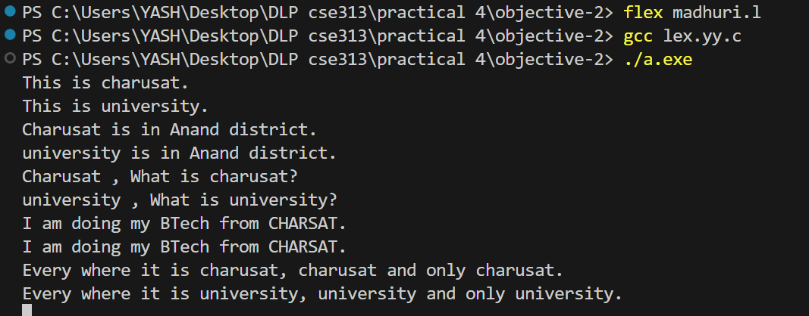

Objective-3

Test cases:  
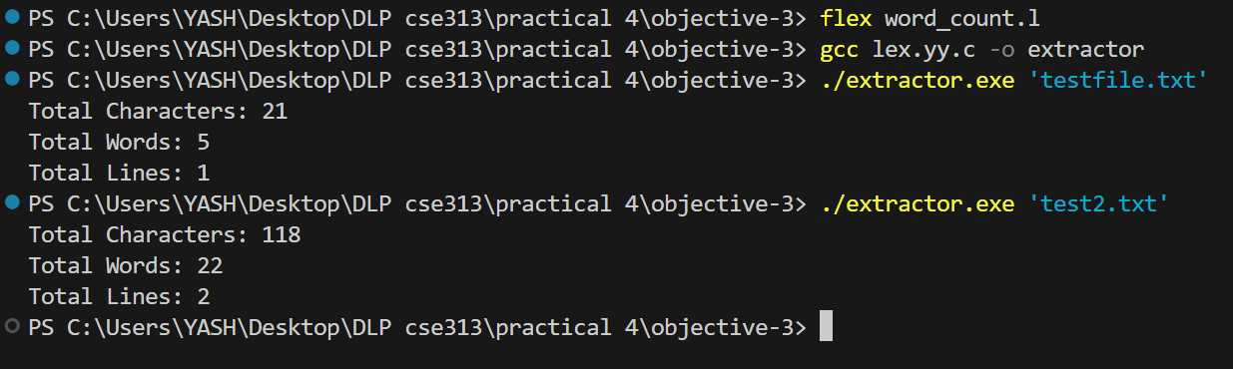

Objective-4

Test cases:

